**Smart Office Cleaner Robot**

Manmeswar Patnaik1, Yashwardhan Kaushik2,

Natasha Karanjia3, Uppalapati Bindu Sri Sai4, Abhinav Patil5, Ajay dev Parmar6, Sanchit Kumar7

*1 Student,Dept. of Mechanical Engg ,Parala Maharaj Engineering College,Berhampur,Odisha,India*

*2 Student , Dept Mechatronics Engg, Manipal University,Jaipur,India*

*3 Student, Dept of Information And Technology,Amity University,Mumbai,India*

*4 Student, Dept.of Computer Science and Engg ,VNR Vignana Jyoti Institute of Engineering and Technology, Hyderabad, India*

*5 Student, Dept. of Architecture Engg ,Aayojan Schhol of Architecture and Design, Pune,India*

*6 Student, XI , Computer Science,Jawahar Navodaya Vidyalaya Kundeshwar, Tikamgarh M.P., India*

*7 Student, Dept.of Mechanical Engg, MIT Academy Of Engineering,Pune,India*

**Abstract:** *The technology is advancing rapidly and with these advancements robots are getting more used up by researchers to ease the mankind and provide comfort. This paper presents the development of an innovative product Smart office cleaner and describes the development and fabrication of the same. The subject product works both ways i.e. in autonomous as well as manual mode with features like dry cleaning , wet moping , UV sanitisation , terrain mapping and smartphone connectivity. This can be very helpful in providing mankind comfort.*

***Index Terms*—** **Wi-fi Microcontroller , Motors with wheels(DC, Servo) , LIDAR sensor , PIR sensor**

**RTC Module**

1. **INTRODUCTION**

In recent years, robot cleaners have been a major source in robotics research due to their effectiveness in being helpful for floor cleaning applications at homes, restaurants, offices, hospitals, warehouses and universities etc. Basically, robot cleaners are differentiated on their cleaning like floor mopping, dry vacuum cleaning etc. Some products are based on simple obstacle avoidance using infrared sensors while some terrain mapping technique. Each cleaning and operating robotic cleaners has its own advantages and disadvantages. The objective of this project is to provide a sustainable solution to the problem of manufacturing smart cleaning robot utilizing minimum resources at lower costs.

In this project , smart floor cleaning robot has been designed for consumer/office environments. Main objective is to prepare robust , inexpensive, affordable product with better efficiency Proposed design operates in dual modes, in one of the modes,

the robot is fully autonomous and making decisions on the basis of the outputs of the driving circuitry.

Also through the manual mode, the robot can also be handled in areas difficult to reach.

This paper is arranged in seven sections. Introduction to this project is discussed in Section I . A detail literature review of robot cleaners is described in Section II. Section III covers the mechanical design of robot including exterior design, brushing ,vacuum cleaning mechanism and UV sanitisation mechanism .Electronic circuitry (including motors , vacuum pump controller, LCD screen and LIDAR sensor along with safety circuit for power supply to sensors, is discussed in Section IV. Section V includes description of android application developed for controlling the bot. Section VI i.e. The conclusion is concludes the entire objective of this project and describe the whole idea of this project.

1. **LITERATURE REVIEW**

A smart office cleaner is an autonomous electronic device that is efficiently programmed to clean a specific area through a vacuum cleaning assembly. Some of the available products can brush around sharp edges and corners while others include a number of additional features such as wet mopping and UV sterilization rather than vacuuming. Some of the available products are discussed below.

The availability of labour for household has now become a serious challenge, and this is to even become worse in developed economies in the coming times. In the past, the concept of robots in domestic environments sounded like a luxury, but

due to striking local labour force, the use of service robots for the internal environment is becoming an economically sensible choice, particularly across high labour-cost countries.

1. **MECHANICAL DESIGN**

Parts to be fitted:

1. Brushes
2. Mop roller
3. Water cylinder
4. UV Sanitisation

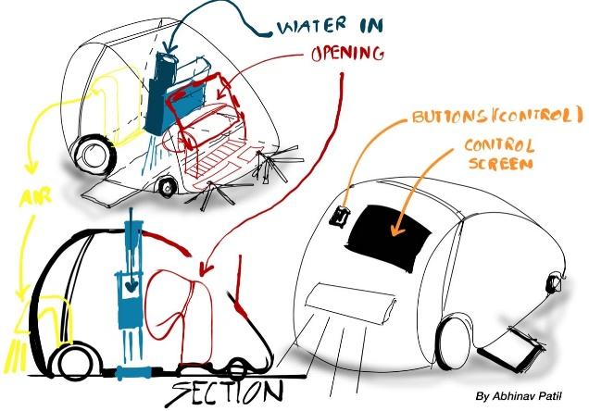

**Fig 1:** Proposed prototype design

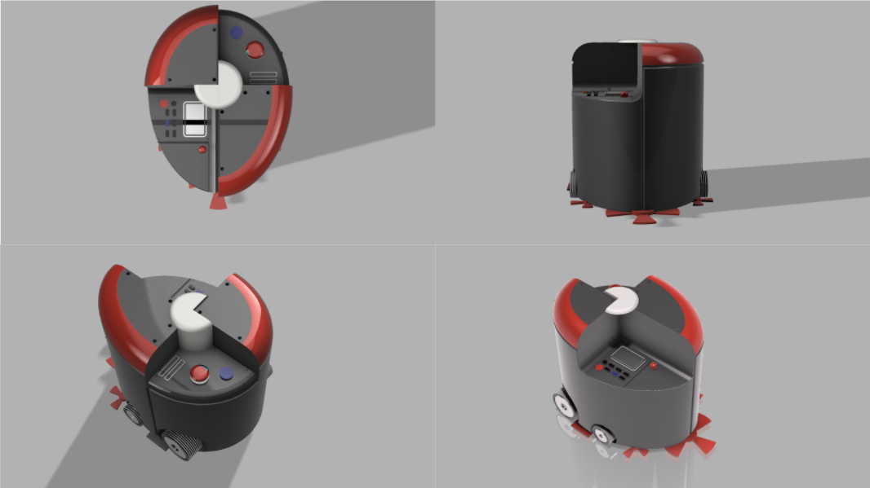

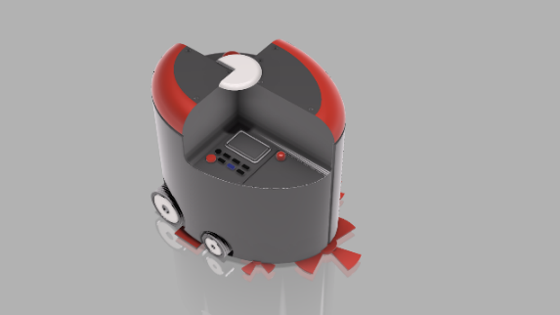

**Fig 2**: Final prepared 3D model design

Brushes:

There will be a pair of small brush and a big

brush placed in position of triangle edge, which will

provide balance to the model .The bigger brush is to

provide more cleaning area covered within this

compact model.

Mop roller: Wet mop to be attached within, to assemble multiple cleaning process. This mop roller will clean the area under after a light cleaning from the brushes and provide finished clean surface.

Water Cylinder: The model will carry water inside the body for wet cleaning by the mop roller .The water will be sprayed and cleaned with mop roller.

UV Sanitisation: Ultraviolet sanitisation will provide cleanliness form harmful bacteria’s and make the environment healthy . Unlike chemical approaches to water disinfection, UV provides rapid, effective inactivation of microorganisms through a physical process

1. **ELECTRICAL CIRCUITRY**

**Components Used and There Uses:**

1. Arduino Mega: Required for the connection and start the sensors.
2. Raspberry Pi: This device is added to control the Arduino and LIDAR mapping.
3. LIDAR/Ultrasonic Sensor: To mapping and detecting. For this project the TFMini is used , ToF (Time of Flight) LiDAR sensor capable of measuring the distance to an object as close as 30 centimetres and as far as 12 meters. Ultrasonic ranging module HC - SR04 provides 2cm - 400cm non-contact measurement function, the ranging accuracy can reach to 3mm.
4. PIR: To detect a moving object. PIR sensors allow you to sense motion, almost always used to detect whether a human has moved in or out of the sensors range.
5. RTC: Real-time clocks (RTC), as the name recommends are clock modules to track the current Time and Date. The DS1307 real-time clock (RTC) IC is an 8 pin device using an I2C interface.
6. DC Gear Motor: To move the wheels of robot.
7. Motor Drivers: We are using L298N Motor Driver  They act as an interface between the motors and Arduino One of the easiest an
8. inexpensive way to control DC motors is to interface L298N Motor Driver with Arduino. It can control both speed and spinning direction of two DC motors.
9. Servo Motors: For rotating the brushes.
10. Battery: For providing extra power supply for heavy sensors.
11. Vacuum Pump: Sucking up the dirt.
12. LCD: For viewing the mode and battery.

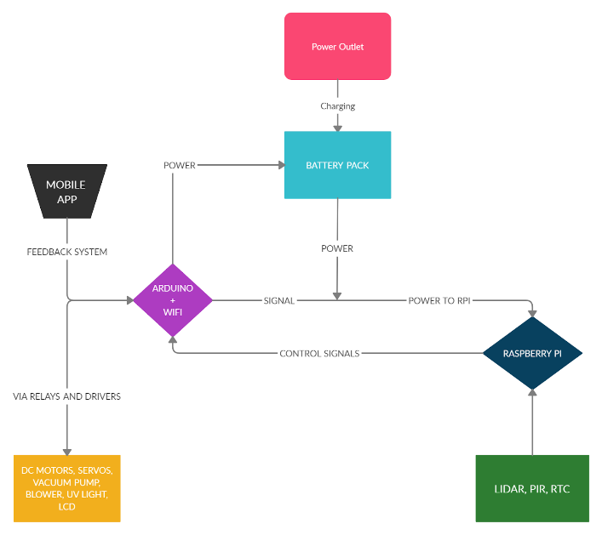

**Fig 3**: Flowchart for the entire process of cleaning

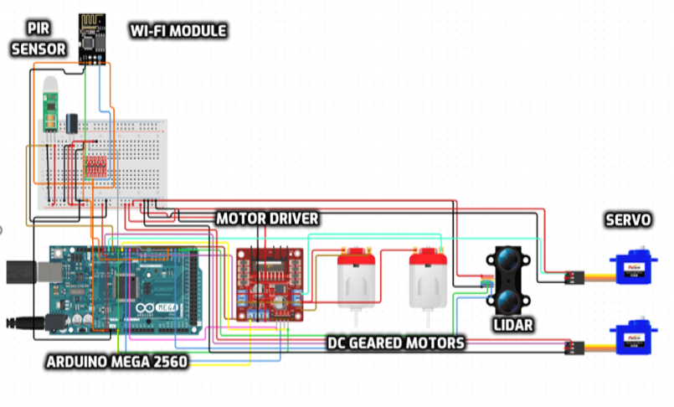

**Fig 4**: Circuit Diagram with all the electronic components

1. **APPLICATION MODE**

Apart from the automatic cleaning an aaplication is also developed so that maual control to the device is also done.

A hardware prototype android mobile application has been developed also forf making floor cleaning process easy, fast and comfortable, for giving commands The app shown below is used to send commands to the robot using the Wi-FI receiver connected to it.

The app consist of 2 screens :

1) Home and 2) Control Panel

Home Screen gives the users basic information and also shows the instruction to connect the device to the WI-FI mode.In wet/dry the machine will perform either wet or dry function as required by the user:

Combo Clean will do both wet and dry cleaning simultaneously and on pressing the STOP buttton the ongoing process will stop completely.

After selection of the required mode, the user will move to the control panel in order to control the

movements.The panel has four arrow buttons facing upwards,downwards,left and right direction respectively. Centrally placed is the botton which is Manual/Auto mode.Hence the app is completely user friendly.It is easy to install the app to our android device.

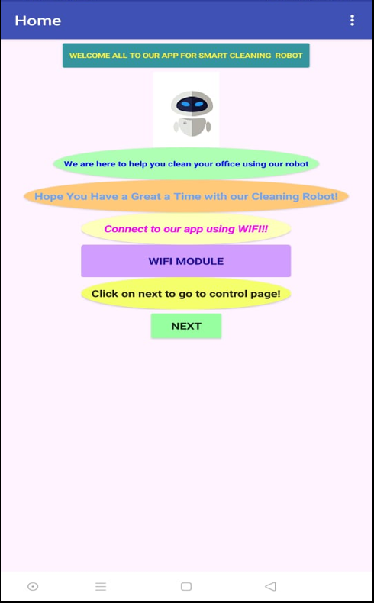

**Fig 5:** Application Hompage

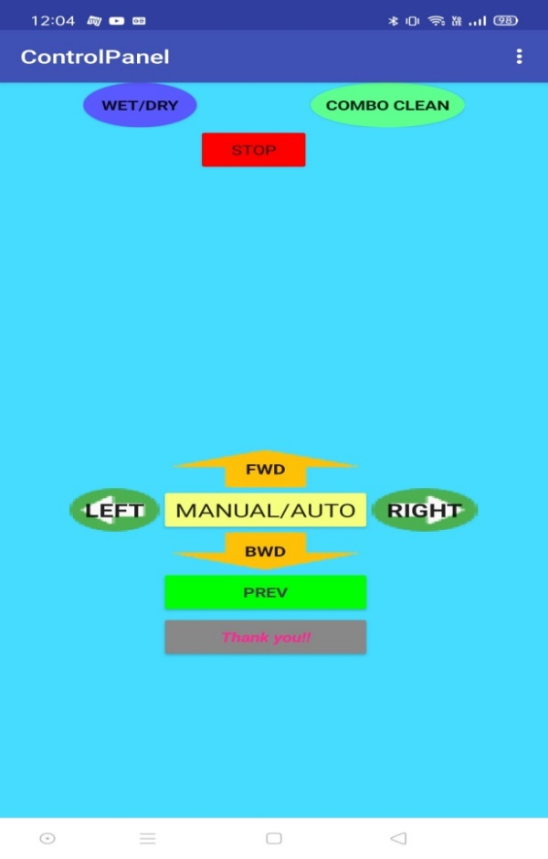

**Fig 6:** Application control panel page

with functions

Control Panel consists of various mode buttons

like WET/DRY ,COMBO CLEAN and STOP.

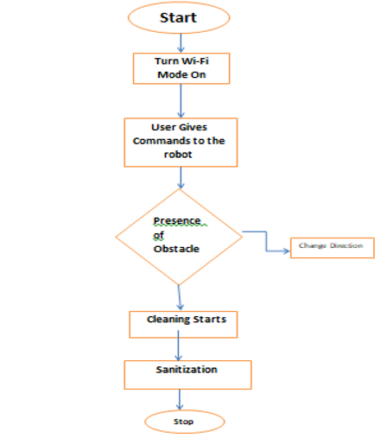

**Fig 7:** Block diag for application working

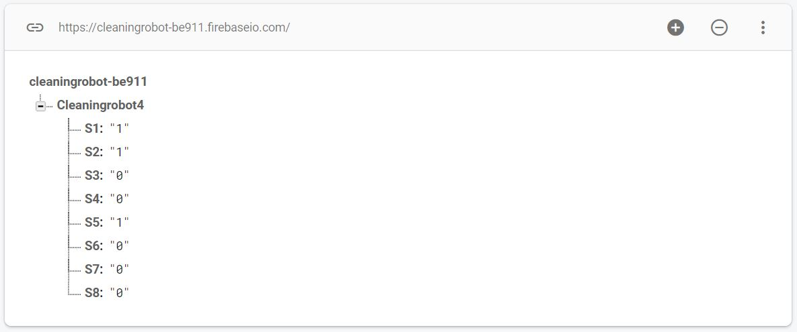

**Fig 8** : Firbase code

<https://drive.google.com/file/d/1uGjQ3rTxsgF8WYT7OMDnzYcQUOxir58F/view?usp=sharing>

1. **CONCLUSION**

The main objective of this project is to make a vacuum cleaning robot which is fully autonomous and manual featured with user friendly interface.

The vacuum cleaner is able to clean, brush and UV sanitisation. The smart robot is developed for office premesises and can work accordingly in many different environments. It has variable speed and power efficient. This smart office cleaner can be used in autonomous and manual modes as per user’s will. During its autonomous mode, this bot will work efficiently and provide cleanliness.

Customers are provided with the user friendly interface to operate the robot without any difficulty. The paper shows a better and simple approach to provide an overview of design of a simple robotic cleaners control design using gadgets and instruments easily.

1. **REFERENCES**
2. https://blogs.nvidia.com/blog/2019/07/25/what-is-simultaneous-localization-and-mapping-nvidia-jetson-isaac-sdk/
3. https://www.instructables.com/id/CleanSwCle-the-Floor-Cleaning-Robot/
4. https://learn.trossenrobotics.com/projects/154-lidar-light-getting-started-guide.html
5. https://dronebotworkshop.com/getting-started-with-lidar/
6. https://create.arduino.cc/projecthub/avirup_basu/autonomous-navigation-and-2d-mapping-0f91d3
7. Arun T S , Prof. Krishna S “Autonomous 2D Mapping of an Unknown Environment using Single 1D LIDAR and ROS” ISSN: 2278-0181
8. KUSHAL N L , HAMARA CHAUDHURI , NIKITHESH H R “AUTONOMOUS FLOOR CLEANING BOT “